22->22. Find the names of students who have taken courses in both "Fall" and "Spring"
semesters.

select name from student
join takes on student.id=takes.id
where takes.semester in ('Fall','Spring')
group by student.id,student.name
having count(distinct takes.semester) =2
;
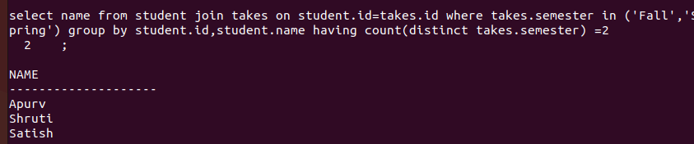

23->Retrieve the names of instructors who have taught more than 5 sections

SELECT instructor.name
FROM instructor
JOIN teaches ON instructor.ID = teaches.ID
GROUP BY instructor.name
HAVING COUNT(teaches.course_id) > 5;



24->>List all courses that have no prerequisites.

SELECT course_id FROM course WHERE course_id NOT IN (SELECT course_id FROM prereq);
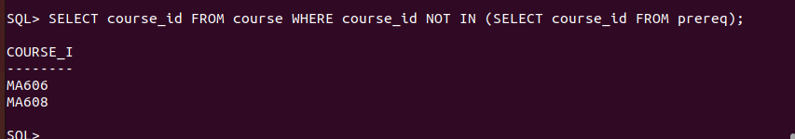

25. Find the average number of credits taken by students in each department.

SELECT debt_name, AVG(tot_cred) AS avg_credits FROM student GROUP BY debt_name;

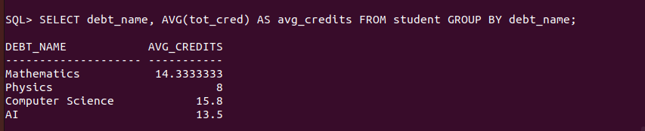

26. Retrieve the names of students who have taken courses with the instructor "Einstein".

SELECT DISTINCT student.name
FROM student
JOIN takes ON student.ID = takes.ID
JOIN teaches ON takes.course_id = teaches.course_id
JOIN instructor ON teaches.ID = instructor.ID
WHERE instructor.name = 'Dr. Mahima';
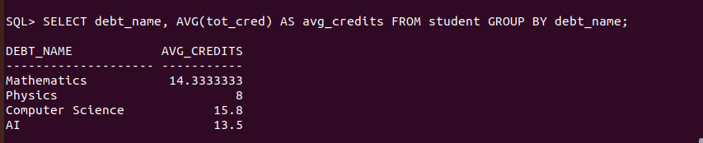

27. List all sections that are held in the "Watson" building.

select * from section where building='main';

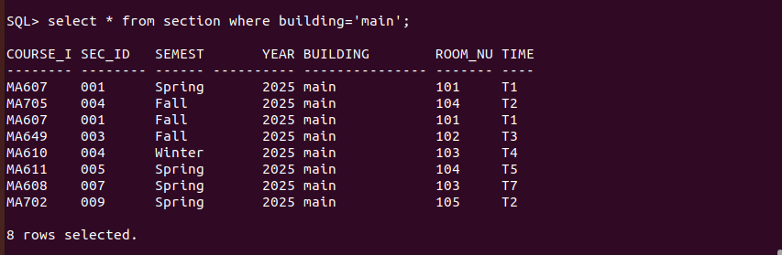

28. Find the total budget allocated to all departments.

SELECT course_id FROM course WHERE course_id NOT IN (SELECT course_id FROM prereq);
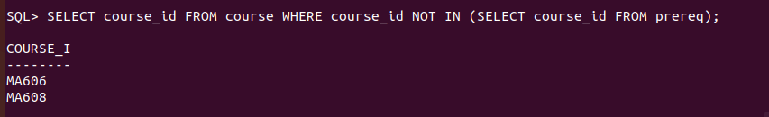
29. Retrieve the names of students who have taken at least one course with a grade of "B".

SELECT DISTINCT student.name
FROM student
JOIN takes ON student.ID = takes.ID
WHERE takes.grade = 'B';

30. List all instructors who have not taught any courses.

select name from instructor
where id not in(select id from teaches)
;



31. Find the names of students who have taken all courses offered by the "Computer
Science" department.

SELECT s.name
FROM student s
WHERE NOT EXISTS (
SELECT course_id FROM course
WHERE debt_name = 'Mathematics'
MINUS
SELECT course_id FROM takes
WHERE takes.ID = s.ID
);
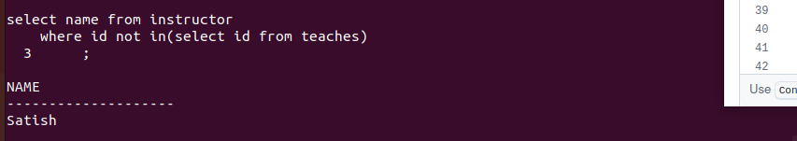

32. Retrieve the names of instructors who have taught every course in their department.

select i.name
from instructor i
where not exists(
select course_id from course
where debt_name=i.debt_name
MINUS
select course_id from teaches
where teaches.id=i.id);



33. List all students who have taken at least one course with every instructor in their
department.

select s.id,s.name,s.debt_name
2 from student s
3 join takes t on s.id=t.id
4 join teaches ts on t.course_id =ts.course_id
5 join instructor i on ts.id =i.id and i.debt_name =s.debt_name
6 group by s.id,s.name,s.debt_name
7 having count (distinct i.id)=(select count(distinct i2.id) from instructor i2
8 where i2.debt_name=s.debt_name);

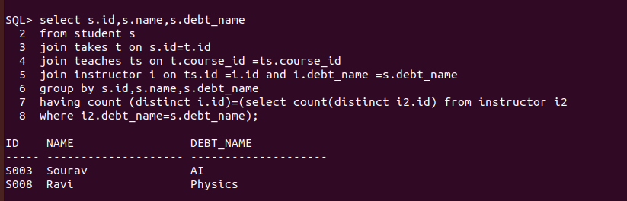
34. Find the courses that have the highest number of prerequisites.

SELECT course_id
FROM prereq
GROUP BY course_id
HAVING COUNT(*) = (SELECT MAX(COUNT(*)) FROM prereq GROUP BY course_id);

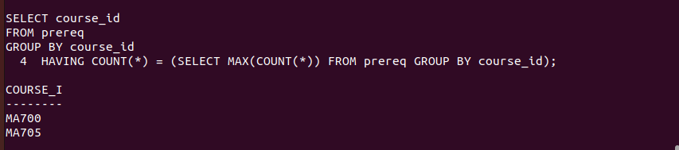
35. Retrieve the names of students who have taken the same course more than once

SELECT s.name
FROM student s
JOIN takes t ON s.ID = t.ID
GROUP BY s.name, t.course_id
HAVING COUNT(*) > 1;

